MIT 8103: CA Submission
Student: Chidubem Asogwa (301928798) ·
Course: MIT 8103 Advanced Database Systems, MIVA Open University ·
Case study category: Hospital / Clinic System ·
GitHub: github.com/da-craftsman/Asogwa_Chidubem_301928798

1. Case study
The Craftsmen Clinic is a simulated outpatient clinic in Nigeria, under the brief's Hospital / Clinic System category. I chose it because I intend to build hospital management and doctor booking systems. This Clinic has five departments, a laboratory, and a pharmacy. Users: receptionists, clinicians, lab scientists, pharmacists, and an administrator. Data: patients, clinicians, departments, appointments, diagnoses, prescriptions, pharmacy stock, lab orders, and lab results. Operations: register patients, book appointments without double booking, record diagnoses, prescribe and dispense, order tests, record results, and retrieve a patient's history. Inpatient functions such as wards and admissions are out of scope, and all data is synthetic.

2. Portfolio 1: Database design and modeling
I designed a PostgreSQL schema of 10 tables: nine core entities (patients, clinicians, departments, appointments, diagnoses, medications, prescriptions, lab tests and lab orders) and one link table, prescription_item, connecting prescriptions to their medicines. Primary keys identify each record, foreign keys link related tables, and NOT NULL, UNIQUE, and CHECK constraints enforce the clinic's rules, such as no double booking and no negative stock. All 12 deliberately invalid statements in my constraint tests were rejected. I normalized a paper visit form from UNF to 3NF, and a join query rebuilt the original rows exactly, showing no information was lost.
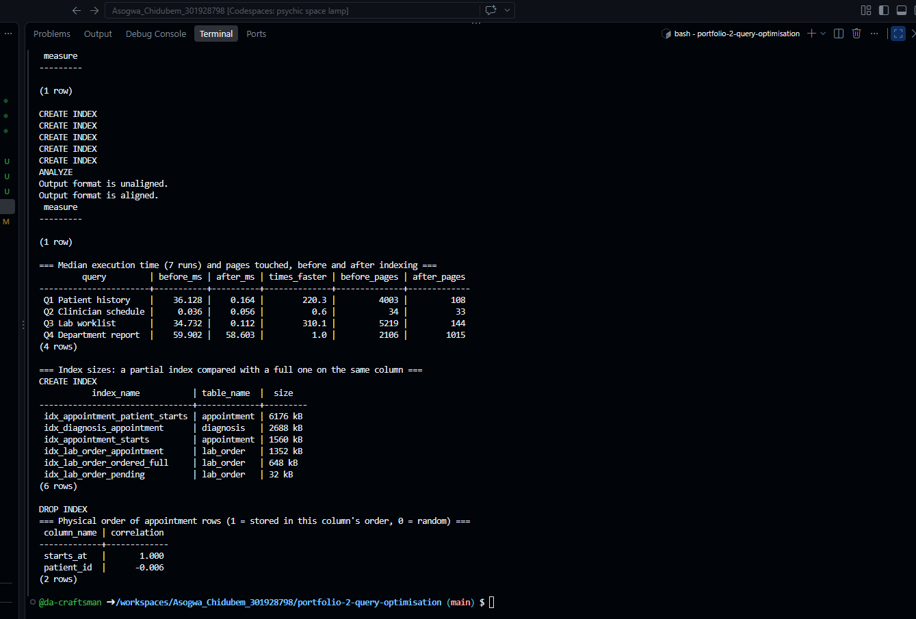

3. Portfolio 2: Query processing and optimization
I loaded 200,000 appointments and related records with a seed script, then measured four clinic queries with EXPLAIN (ANALYZE, BUFFERS), taking the median of 7 runs before and after indexing (Figure 2).
Query | Before → after (ms) | Finding
Patient history | 36.1 → 0.16 | 220× faster: foreign keys are not indexed automatically, so I added a composite index
Lab worklist | 34.7 → 0.11 | 310× faster with a 32 kB partial index holding only pending orders
Clinician schedule | 0.04 → 0.06 | Already fast: the double-booking constraint had created a matching index
Department report | 59.9 → 58.6 | No gain: it reads 44% of the table, so the index is not worth keeping
NB: All other screenshots are in each portfolio's screenshots folder in the repository.

4. Portfolio 3: Transactions and concurrency
One script showed a commit (completing a visit updates five records together), a rollback (a prescription larger than the stock fails, and nothing from it is kept), and a savepoint (one mistaken lab order undone, the rest kept). In two psql terminals acting as two staff members, I reproduced a lost update: stock ended at 480 instead of 470, with no error. I fixed it two ways: SELECT … FOR UPDATE made the second session wait, and REPEATABLE READ made it fail and retry. The Portfolio 1 unique constraint stopped a double booking, and PostgreSQL detected and canceled a deadlock. My first attempts went wrong, so I reset the data and repeated two scenarios.

5. Portfolio 4: NoSQL and advanced data models
I stored detailed lab results in MongoDB as documents, because each test has a different structure: a blood count holds measured values with units. In contrast, a malaria test holds a species and parasite density. Each document carries the same lab order and patient IDs as PostgreSQL. A validator requires the common fields and rejected a result with no patient. Four queries included a search inside a malaria-only field and an aggregation per test, and an index changed the plan from a collection scan (6 documents examined) to an index scan (3). Appointments and stock stay in PostgreSQL, because they rely on constraints and transactions.

6. Portfolio 5: Distributed and cloud database design
This portfolio is a design discussion. PostgreSQL would run one primary, a synchronous standby in a second zone so no confirmed data is lost on failover, and a read replica for reports; MongoDB would run a three-member replica set with majority writes. Sharding is unnecessary, because two years of appointments take only 35 MB. Bookings and stock choose consistency over availability: refusing a booking is safer than double booking. Backups and point-in-time recovery are still needed, because replication copies mistakes too, and database access must be private, not the "allow access from anywhere" setting I saw in MongoDB Atlas.

7. Personal reflection
At first, almost everything confused me, especially a password prompt when installing PostgreSQL in Codespaces and the two-terminal scenarios, where I lost track and had to restart. When my terminal seemed to freeze, I learned it was waiting for a lock held by the other session, the very behavior I was demonstrating.
I now understand the order of the work: design the data, write a schema that sets the rules, load data, then query it, and that early decisions shape later ones. My double-booking constraint also sped up a query and stopped a concurrent booking. At work I use Supabase, which runs PostgreSQL, so SQL was familiar, but execution plans, isolation levels, and locks were new. My main lesson is that a database is not just storage: it is where an application's most important rules are enforced. I want to apply this to the booking systems I build.

8. AI use declaration
GitHub Copilot generated the repository's first skeleton, which was later updated with more practical details. Claude (Anthropic) reviewed that version against the brief, explained concepts, guided me step by step, and drafted most of the scripts, the README text, and this summary from my notes. I used Google/Google Gemini to look up definitions and research. I chose the case study and its scope, ran every script myself in GitHub Codespaces (PostgreSQL 16, MongoDB 7), captured screenshots of my outputs, debugged and repeated failed scenarios, checked every figure against my runs, and reviewed and edited this summary.

9. References
- PostgreSQL Global Development Group. PostgreSQL 16 Documentation: constraints, EXPLAIN, indexes, transaction isolation, high availability.
- MongoDB, Inc. MongoDB Manual: schema validation, replication.
- Brewer, E. (2012). CAP twelve years later: How the "rules" have changed. Computer, 45(2), 23–29.
- Federal Republic of Nigeria. Nigeria Data Protection Act, 2023.

